Project Title: Data Wearhousing

Phase 4: Development Part 2

**Topic:** continue building the data wear house by implementing ETL processes and enabling data exploration. Implement ETL processes to extract, transform, and load data into the data wear house.

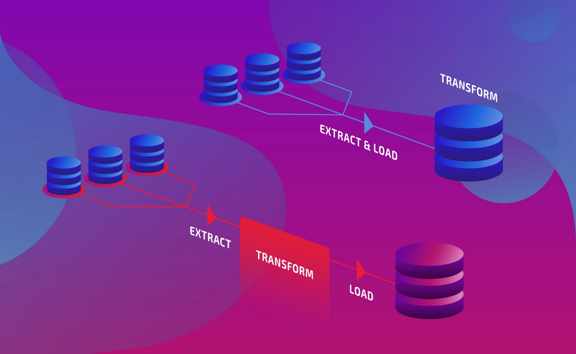

**ETL process**

Introduction:

* Building a data warehouse is a crucial step in modern data-driven businesses. A data warehouse serves as a centralized repository for collecting, storing, and managing large volumes of data from various sources. To harness the full potential of the data within a data warehouse, it's essential to implement ETL (Extract, Transform, Load) processes that facilitate the movement, transformation, and loading of data into this repository
* ETL processes are the backbone of a data warehouse, enabling organizations to make informed decisions by providing timely, accurate, and well-structured data. In this document, we will explore the critical steps involved in implementing ETL processes and enabling data exploration within your data warehouse.

Given data set:

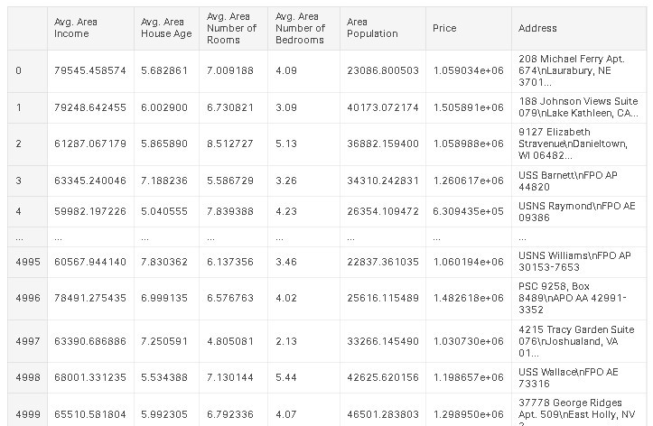

5000 Rows x 7 Columns

**Overview of the process:**

The ETL (Extract, Transform, Load) process is a foundational step in constructing a data warehouse. It encompasses a series of tasks that enable organizations to collect, transform, and load data from diverse sources into a central repository. This comprehensive overview will guide you through the critical phases of the ETL process:

1. **Data Extraction:**

* Source Identification: Begin by identifying the various sources of data within your organization. These sources may include databases, cloud storage, data lakes, external systems, APIs, and more.
* Data Retrieval: Extract data from the identified sources. This can involve querying databases, leveraging APIs, or using other techniques to obtain raw data. Consider data extraction methods that align with the characteristics of each source.
* Data Profiling: Conduct an initial data profiling to understand the content, structure, and quality of the extracted data. This step aids in identifying data anomalies, inconsistencies, and outliers.
* Data Staging: Store the extracted data in a staging area. The staging area acts as an intermediate storage location where data can be cleansed, transformed, and validated before loading it into the data warehouse.

**2. Data Transformation:**

* + Data Cleaning: Cleanse the data to address issues like missing values, duplicates, and data quality problems. Data cleaning processes can involve techniques such as data imputation and outlier detection.
  + Data Enrichment: Enhance the data by incorporating additional information from reference sources. This may include joining data with external datasets to provide context and completeness.
  + Data Aggregation: Aggregate data as needed to create summary tables or metrics that support analytical queries. Aggregation can improve query performance and simplify data analysis.
  + Data Transformation Rules: Define and apply transformation rules that align the data with the structure and requirements of the data warehouse. Transformation rules can encompass data type conversions, reformatting, and more.

**3. Data Loading:**

* + Data Warehouse Schema: Define the schema of your data warehouse. This includes creating tables, specifying column definitions, and establishing relationships between tables. The schema should reflect the business needs and analytical goals of your organization.
  + Loading Methods: Decide on the loading strategy for your data warehouse. Common methods include full refresh (reloading all data) and incremental loading (updating only changed or new data). Choose a method that suits your data and performance requirements.
  + Data Loading Tools: Employ ETL tools or custom scripts to load the transformed data into the data warehouse. These tools are instrumental in efficiently managing data loading processes, potentially utilizing parallel processing for speed.

**4. Data Exploration:**

* + Data Access Tools: Make the data in the data warehouse accessible to users. Provide tools and interfaces that enable users to query and explore the data. This may include SQL querying, business intelligence tools, data visualization platforms, and reporting systems.
  + Dashboard Creation: Create interactive dashboards and reports that offer insights into the data. Dashboards help users visualize and analyze data, supporting informed decision-making.
  + Data Governance: Establish data governance policies to manage access, security, and compliance. Ensure that sensitive data is adequately protected and that data usage adheres to regulations and best practices.
  + Data Documentation: Document the data in the data warehouse, including metadata, data definitions, and lineage information. Effective documentation assists users in understanding the data's context and appropriate usage.

**1.Data Extraction**

import requests

api_url = 'https://api.example.com/data'

params = {'start_date': '2023-01-01', 'end_date': '2023-12-31'}

response = requests.get(api_url, params=params)

data = response.json()

**2.Data Tranformation**

import pandas as pd

data = pd.read_csv('data.csv')

data = data.dropna()

data['date'] = pd.to_datetime(data['date'])

daily_summary = data.groupby('date').sum()

**3.Data Loading**

-- Connect to the data warehouse

\c mydatawarehouse

-- Create a table if it doesn't exist

CREATE TABLE IF NOT EXISTS mytable (

date DATE,

revenue NUMERIC

);

-- Insert data into the data warehouse table

INSERT INTO mytable (date, revenue)

SELECT date, SUM(revenue) FROM staging_table

GROUP BY date;

